FREQUENCY DIVIDER

What is a frequency divider?
A clock frequency divider takes an input clock signal at frequency f and outputs a slower signal at f/n. Think of it like a gear — if you spin an input gear fast, the output gear spins slower in a predictable ratio.

What is a MOD-N Counter?
- A counter that counts from 0 to N-1, then resets to 0
- MOD-3 counts: 0 → 1 → 2 → 0 → 1 → 2 → ...
- MOD-5 counts: 0 → 1 → 2 → 3 → 4 → 0 → ...
- Its output bits naturally encode f/N signals — we just need to pick the right one

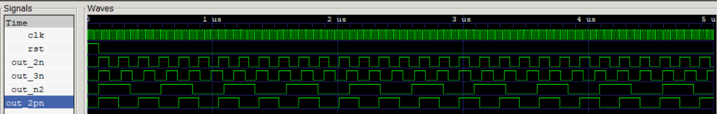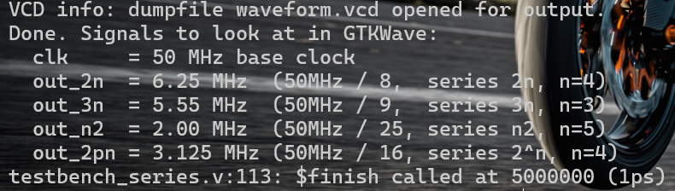

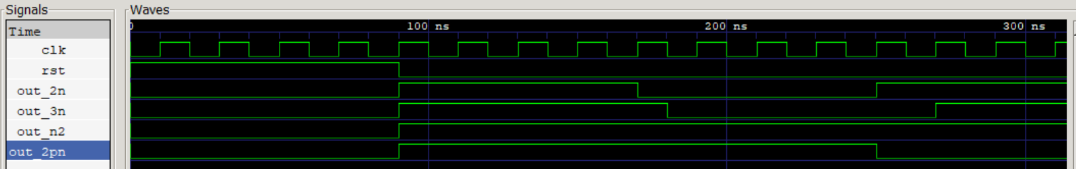
WAVEFORM ANALYSIS:
1) clk (base clock):
Frequency: 50 MHz | Period: 20ns | Duty Cycle: 50%
This is the source clock. Every other signal is derived from this. It flips- HIGH for 10ns, LOW for 10ns. This is the reference against which everything else is measured.

2) out_2n
Frequency: 6.25 MHz | Period: 160ns | Duty Cycle: 50%
out_2n completes exactly 1 cycle for every 8 cycles of the clk
HIGH for 4 clock ticks, LOW for 4 clock ticks, 80ns each
Duty Cycle= exactly 50% (HIGH and LOW for 4 ticks each)
Since N=8(even) no flip flop was needed

3) out_3n:
Frequency: 5.55MHz | Period: 180ns | Duty Cycle: 50%
out_3n completes exactly 1 cycle for every 9 cycles of clk
Without the fix: it would be HIGH for 4 ticks (80ns), LOW for 5 ticks (100ns) -> 44% duty cycle
After the −ve edge FF + OR fix: HIGH for 4.5 ticks (90ns), LOW for 4.5 ticks (90ns) -> 50%
N=9 is odd — this is where you can clearly see the effect of the negative edge flip-flop doing its job

4) out_n2
Frequency:2 MHz | Period: 500 ns | Duty Cycle: 50%
out_n2 completes 1 cycle for every 25 cycles of clk
Without fix: HIGH for 12 ticks, LOW for 13 ticks -> 48%
After the -ve edge FF + OR fix: HIGH for 12.5 ticks, LOW for 12.5 ticks -> 50% duty cycle
N=25 (odd) – this is where you can clearly see the effect of the negative edge flip-flop doing its job

5) out_2pn
Frequency: 3.125 MHz | Period: 320ns | Duty Cycle: 50%
out_2pn completes 1 cycle for every 16 clk ticks
HIGH for exactly 8 ticks, LOW for exactly 8 ticks
N=16(even), therefore no flip flops needed.

